**Requirement Specification**

**LiveShop**



|  |  |  |  |
| --- | --- | --- | --- |
| Submission date |  | Team | Team 1 |
| Course | Software architecture | **Professor** | Eunseok Lee |
| name | Hyung-Joon Jeon | **student ID** | 2019712410 |
| name | PHAM CONG VINH | **student ID** | 2019711010 |
| name | MWASINGA LUSUNGU | **student ID** | 2019711011 |
| name | VO VAN VI | **student ID** |  |
| name | Taekwon Ka | **student ID** | 2013314340 |

목차

1. User Requirements Definition 4

1.1. Functional Requirements 4

A. Sign up/Sign In 4

B. Live Streaming 4

C. Live Chat 4

D. Disclosure of Product Information 4

E. Store 5

F. My page 5

G. Option 5

1.2. Non-functional Requirements 5

A. Product requirements 5

2. System Architecture 8

2.1. Functional Requirements – Frontend 8

A. Show Item Detail 8

B. Show the Recommendation List 8

C. Add Categorized Items 9

D. User Account 9

2.2. Functional Requirements – Backend 10

A. Login 10

B. Browsing history gathering system 11

2.3. Non-Functional Requirements 11

A. Product requirements 11

B. Organization Requirements 12

C. External Requirements 13

3. System Models 13

3.1 Frontend Diagram 13

3.2 Backend Diagram 14

3.3 Usercase Diagram 15

1. User Requirements Definition

This section covers the definitions for the user requirements of the proposed system. The requirements can be categorized into functional and non-functional requirements.

1.1 Functional Requirements

The functional requirements include, but are not limited to, the following items:

1. Sign up/Sign In

* This is basic requirement for users to use the Liveshop application. At first, Users create an account of our system with ID, password and some personal information such as name, address, e-mail. After that, users can sign in the system with ID, Password. When uses sign in, system should authenticate the user by matching given information with account information in the DB.

1. Live Streaming
   * The system must support live streaming services in order to enable the show host(s) to advertise products to be sold. On the live streaming screen, users can follow the seller or press “Like” button.
2. Live Chat

* The system must enable prospective customers to type in various comments such as reviews and questions about the product. The comments written are delivered by pressing the “Send” button.
* Show hosts and advertisement committees must be able to give feedback on the customers’ comments.

1. Disclosure of Product Information
   * Aside from what is shown in the live-streamed advertisement, the system must display all the essential information that describes the product to be sold in detail.
2. Store

* Store allows users to buy products even if they are not on the air. All products are categorized according to their product groups, and each product has their own product information and VOD recorded in the live streaming. In addition, users can purchase products while viewing the product information..

1. My page

* My page provides users with information related to ordering and activity. Users can check their orders and the shipping information for the order. The system informs users of the preferred product categories through user’s activity history, and the product information introduced by sellers followed by the user.

1. Option

* On the "Option" page, users can set options related to the application. For example, you can set an alarm for live broadcast information from user following seller and also set video quality depending on the network environment.

1.2 Non-functional Requirements

The non-functional requirements can be further classified into Product Requirements, Organizational Requirements, and External Requirements as follows:

1. Product Requirements
   1. Performance
      * The system should have little problems in loading and delivering live-streamed session to the customer on time. The Live Streaming service must be able to deploy video frames of maximum quality supported by the mobile hardware on which the video is being streamed (mostly 1080p). Otherwise, it should deploy the quality as selected by the user’s choice. In addition, as the name suggests, the live-streamed session should virtually have no delay compared to the time point of recording through studio camera. Ideally, the only tolerable delay is the transmission delay: the time it takes to transfer frames of live-streamed video towards the user.
      * The system should have little problems in providing live chatting service. Besides free of bottlenecks in typing in messages in the textbox of Live Chat, a customer’s comment must be delivered to advertisers and other customers immediately after the “Send” button is clicked.
   2. Security
      * The system should not be prone to hacking. Sensitive information related to a customer, especially personal information, must be securely stored in the database such that nobody else than the corresponding person oneself is able to access and modify it.
      * Live Streaming service needs to be protective from video packet sniffing and hijacking. Only the live-streamed video on the relevant product must be advertised throughout the lifetime of advertisement session. Otherwise, customers might get seriously confused.
   3. Power Efficiency
      * Power management issue is crucial to mobile devices that run on battery. Both the Live Streaming and Live Chat service should not consume too much power. Modules that run the services must be put to sleep whenever the software application is closed or set to background state.
   4. Usability
      * The customers should have little problems in pausing of the Live Streaming service, changing the video quality of it, or transitioning the video between windowed and full-screen mode.
      * The customers should have little problems in using the interface provided for Live Chat service.
   5. Integrity
      * The customers have the right to report the product advertisement if it is suspicious of being fraudulent or mendacious. In addition, if the product delivery period is way too long, the customers have the right to report such incident also. The system must provide feature(s) that enable such actions.
      * Although rarely occurring, there are cases when a malicious, ill-mannered user gives out disparaging comments toward the person(s) involved in the show or any other specific social group of persons via Live Chat. The Live Chat feature is also prone to false claims and incorrect conflicting information about the product being advertised, which may be detrimental to product sales. To prevent these cases, the system must provide a service to report abuse of the Live Chat functionality.

2. System Requirements Specification

This chapter specifies the functional and non-functional requirements. We focus on the following detail requirements: Name, description, inputs, source, outputs, destination, action, requirements, pre-condition.

2.1 Functional Requirements – Frontend

1. Show Item Detail

|  |  |
| --- | --- |
| Name | Show Item Detail |
| Description | Show the inner structure of each individual object in the recommendation list |
| Inputs | string representing the product name |
| Source of Input | From user |
| Outputs | Recorded videos comprising the details related to a specific searching item |
| Destination of Output | User terminal |
| Action | Once the user search for the item or clicks from the recommendation list, the selected item’s name is propagated to the backend and subsequently, information related to this item is returned to the user. The returned information is a recorded video or a livestream video. |

1. Show the Recommendation List

|  |  |
| --- | --- |
| Name | Show video recommendation list |
| Description | Show video recommendation list based on user’s shopping patterns using Artificial Intelligence (AI) |
| Inputs | - |
| Source of Input | Information retrieved from the backend |
| Outputs | A list of videos displayed based on the user’s shopping patterns |
| Destination of Output | User terminal |
| Action | Once the user selects a video item from the recommendation list, the selected item’s name is propagated to the backend and subsequently, information related to this item is returned to the user. |

1. Add Categorized Items

|  |  |
| --- | --- |
| Name | Add the categorize item function |
| Description | Categorize all items based on their usage, i.e., Kitchen appliances, electronics, clothing, etc. |
| Inputs | - |
| Source of Input | - |
| Outputs | A list of item categories. |
| Destination of Output | User terminal |
| Action | Once the user selects a category, a list of item names will be propagated to the backend and subsequently, information related to this category is returned to the user. |

1. User Account

|  |  |
| --- | --- |
| Name | User account function |
| Description | It is required when the user wants to purchase a their preferred item. |
| Inputs | User ID (a combination of letters and numbers, forming a string of a user’s id), password (a combination of letters and numbers or special characters, forming a string of a user’s password) |
| Source of Input | User authentication and my account button click |
| Outputs | Authenticated user information object |
| Destination of Output | User terminal |
| Action | When a user login or create a new account, a personalized page for the user is created. All previous searching history, user information or delivery tracking information, and the information about their orders is stored in their personal pages. |
| Requirements | User id and password must be specified when the user wants to buy item(s) |
| Pre-condition | Access to “my account” page is only granted to authenticated users |
| Post-conditions | Authorized users can access “my account” page section |

2.2 Functional Requirements – Backend

1. Login

|  |  |
| --- | --- |
| Name | Login Function |
| Description | User authentication and authorization. |
| Inputs | User ID (a combination of letters and numbers, forming a string of a user’s id), password (a combination of letters and numbers or special characters, forming a string of a user’s password) |
| Source of Input | User input |
| Outputs | Authenticated user information object |
| Destination of Output | User terminal |
| Action | Authenticate the user information from input with the information stored in the database. |
| Requirements | User id and password must be specified when the user wants to buy item(s) |
| Pre-condition | Access to “my account” page is only granted to authenticated users |
| Post-condition | Authorized users can access “my account” page section |

1. Browsing history gathering system

|  |  |
| --- | --- |
| Name | Browsing history gathering system function |
| Description | This function tracks and collects the browsing history for the current user from multiple sites they have visited in the past |
| Inputs | - |
| Source of Input | Users past browsing history |
| Outputs | A list of parsed recommended items |
| Destination of Output | User terminal |
| Action | Gathering the search history from the internet and perform some statistics to identifying some trending items. |

2.3 Non-Functional Requirements

1. Product requirements
2. Usability

* It is a fundamental requirement that results in a successful website or E-commerce platform. A simplistic and intuitive user interface should be implemented in order to make it easy for users to navigate the system. The proposed system’s user interface has few buttons and tabs which have a contrast that makes it easy for user to quickly adapt to the different sections.
* Users can access the system using a variety of devices such as mobile phones, tablets, desktop monitors, and large screens because the it is developed to be compatible with a wide range of device platforms.

1. Performance

* The web browsing history analysis functionality of the system should be able to handle several exceptions in order to extract and curate reliable web browsing history results for a target customer. The performance of this component is crucial to the recommendation system offered by the application. Therefore, the algorithm for determining recommendations is also expected to be robust in order to provide satisfactory recommendations to users. Furthermore, it is expected that the rate of updating the recommendation list will be reasonable in order to allow customers have access to new videos and consequently new products.

1. Dependability

* The system is expected to be as highly dependable as possible. To achieve property, it is expected that all actions will be executed atomically. This entails that in case system failures occur in the course of a critical transaction or operation, the intended changes or operation will not be aborted/discarded. In addition, in case of any hardware failures, the system is expected to reset to the most recent known state in which the system operated smoothly. To guarantee dependability in terms of recommendation list reviews, the browsing history analysis module will be augmented by Google Natural Language processing system.

1. Security

* All personal records held in the system will be made secure from any unauthorized access. The intention is to implement a robust authentication and authorization process that will be less prone to any forms of malicious attacks.

1. Organization Requirements
2. Operational

* The system is built on Cloud Platform to minimize the infrastructure costs that host the website. The hardware is eliminated, then focusing more on upgrading the functionalities for the system and finding a good service provider who can provide the needs and security of the system.

1. Development

* Design a software process that is suitable with the requirement time, or number of team members, etc. Parallel development is one of the best choices to fasten the development stage as well as increase the development efficiency. Applying the plan driven approach that helps the work is distributed to developers, they can work simultaneously. The outputs are tested independently or pair-reviewed.

1. External Requirements
2. Personal information Protection

* The system collects and stores user information when they sign up to the webpage. Only some basic information of users is gathered and of course every personal information should be confidential to get trusted from the users.

3. System Models

3.1 Frontend Diagram

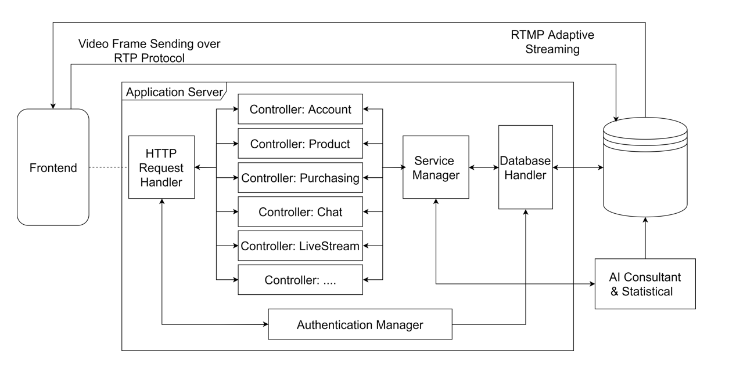

3.2 Backend Diagram

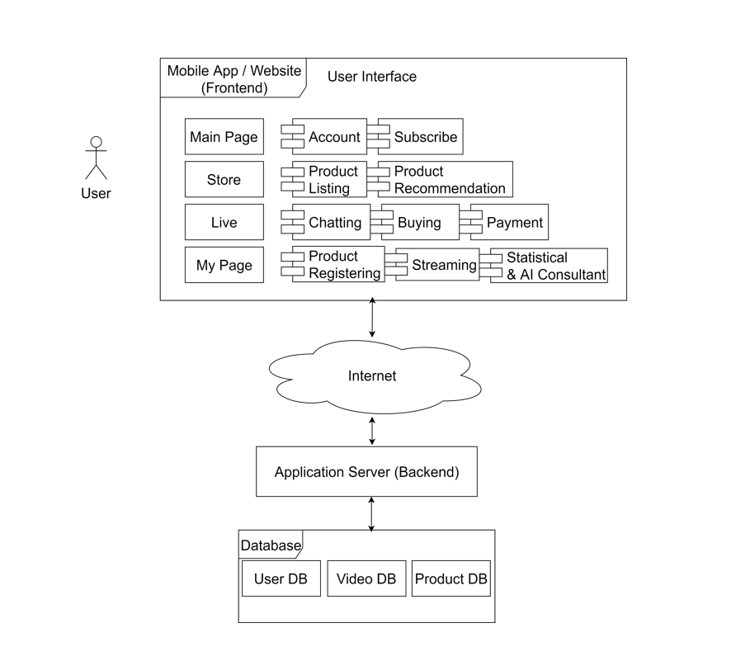

3.3 Usercase Diagram

